**EXP NO: 9**

**AIM:**To find the largest number from an array using 8085 processor.

**ALGORITHM:**  
1)      Load the address of the first element of the array in HL pair.   
2)      Move the count to B register.   
3)      Increment the pointer.   
4)      Get the first data in A register.   
5)      Decrement the count.   
6)      Increment the pointer.   
7)      Compare the content of memory addressed by HL pair with that of A register.   
8)      If carry=0, go to step 10 or if carry=1 go to step 9   
9)      Move the content of memory addressed by HL to A register.   
10)  Decrement the count.   
**PROGRAM:**  
LXI H,2050   
MOV C,M   
DCR C   
INX H   
MOV A,M   
LOOP1: INX H   
CMP M   
JNC LOOP   
MOV A,M   
LOOP: DCR C   
JNZ LOOP1   
STA 2058   
HLT   
**INPUT:**  
  
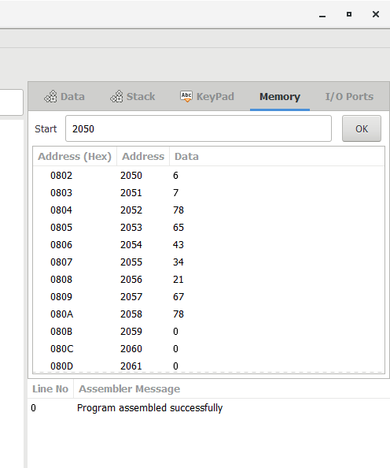  
  
**OUTPUT:**

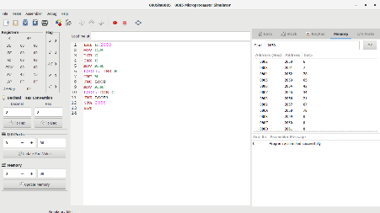  
  
   
  
**RESULT:**Thus the program was executed successfully using 8086 processor simulator.